8. Exercícios: Construir, simular e determinar a tabela verdade dos circuitos representados pelas expressões lógicas abaixo:

- S = (A + B).(~B + C)

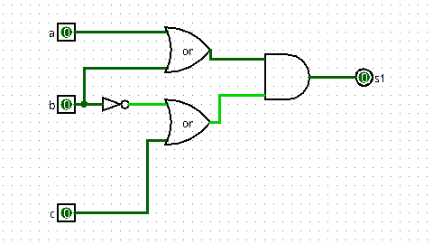

S = (A + B).(~B + C)
A | B | C | ~B | A+B | ~B+C | S
1 | 1 | 1 | 0 | 1 | 1 | 1
1 | 1 | 0 | 0 | 1 | 0 | 0
1 | 0 | 1 | 0 | 1 | 1 | 1
1 | 0 | 0 | 0 | 1 | 0 | 0
0 | 1 | 1 | 1 | 1 | 1 | 1
0 | 1 | 0 | 1 | 1 | 1 | 1
0 | 0 | 1 | 1 | 0 | 1 | 0
0 | 0 | 0 | 1 | 0 | 1 | 0

- S = A.C + ~(B.C) + ~A.B.C
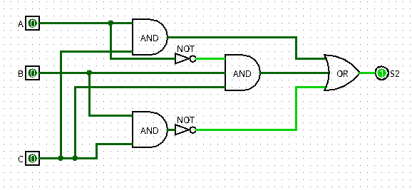

A | B | C | A.C | ~(B.C) | ~A | ~A.B.C | S
1 | 1 | 1 | 1 | 0 | 0 | 0 | 1
1 | 1 | 0 | 0 | 1 | 0 | 0 | 1
1 | 0 | 1 | 1 | 1 | 0 | 0 | 1
1 | 0 | 0 | 0 | 1 | 0 | 0 | 1
0 | 1 | 1 | 0 | 0 | 1 | 1 | 1
0 | 1 | 0 | 0 | 1 | 1 | 0 | 1
0 | 0 | 1 | 0 | 1 | 1 | 0 | 1
0 | 0 | 0 | 0 | 1 | 1 | 0 | 1

S = A.B + ~C + ~(C.D)

- Z = X.(~Y + W)

